Apply filters to SQL queries

Project description
As part of my responsibility to enhance the system's security, I diligently worked on investigating potential security issues and updating employee computers when necessary. To accomplish these tasks, I employed SQL queries with filters, which allowed me to address security-related concerns effectively. The following steps demonstrate how I utilized SQL to perform these tasks.

Retrieve after hours failed login attempts
There was a potential security incident that occurred after business hours (after 18:00)
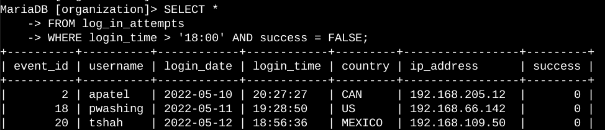
The provided query filters for failed login attempts that occurred after 18:00. By selecting data from the "log_in_attempts" table and using conditions within a WHERE clause, the query focuses on retrieving only the unsuccessful login attempts that took place after 18:00.

Retrieve login attempts on specific dates
A suspicious event occurred on 2022-05-09. Any login activity that happened on 2022-05-09 or on the day before needs to be investigated.
The following code demonstrates how I created a SQL query to filter for login attempts that occurred on specific dates.
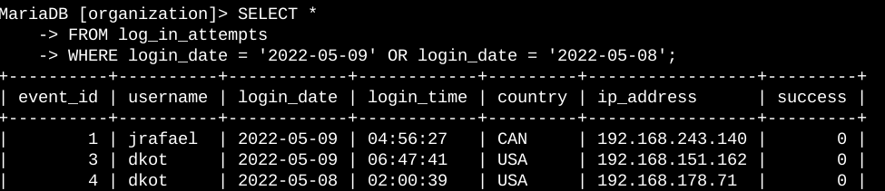
The provided query retrieves login attempts that took place on either 2022-05-09 or 2022-05-08. By selecting data from the "log_in_attempts" table and utilizing a WHERE clause with the OR operator, The query narrows down the results to include only login attempts on those specific dates.

Retrieve login attempts outside of Mexico
After investigating the organization’s data on login attempts, I believe there is an issue with the login attempts that occurred outside of Mexico.
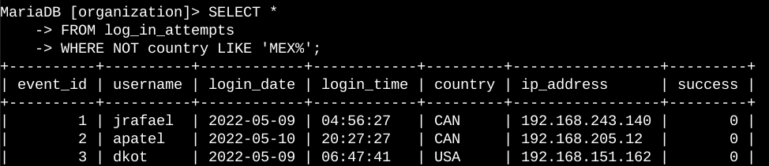
The provided query retrieves login attempts that occurred in countries other than Mexico. By selecting data from the "log_in_attempts" table and using a WHERE clause with the NOT operator, the query filters out login attempts associated with Mexico. To accomplish this, the LIKE operator is employed with the pattern "MEX%," as the dataset represents Mexico as "MEX" and "MEXICO." The "%" sign signifies any number of unspecified characters when used in conjunction with LIKE.

Retrieve employees in Marketing
My team wants to update the computers for certain employees in the Marketing department. To do this, I have to get information on which employee machines to update.
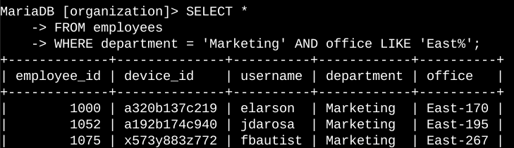
The query retrieves employees who belong to the Marketing department and work in the East building. By selecting data from the employees table and using a WHERE clause with AND, the query filters for employees in the Marketing department and in the office location starting with "East." The condition department = 'Marketing' filters for employees in the Marketing department, while the condition office LIKE 'East%' filters for employees in the East building.

Retrieve employees in Finance or Sales
The machines for employees in the Finance and Sales departments also need to be updated. Since a different security update is needed, I have to get information on employees only from these two departments.
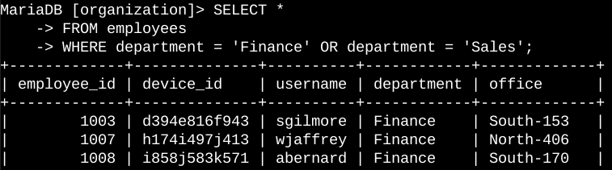
The query retrieves employees who belong to either the Finance or Sales departments. By selecting data from the employees table and utilizing a WHERE clause with the OR operator, the query filters for employees in either the Finance or Sales department. The conditions department = 'Finance' and department = 'Sales' respectively filter for employees from the Finance and Sales departments.

Retrieve all employees not in IT
My team needs to make one more security update on employees who are not in the Information Technology department. To make the update, I first have to get information on these employees.
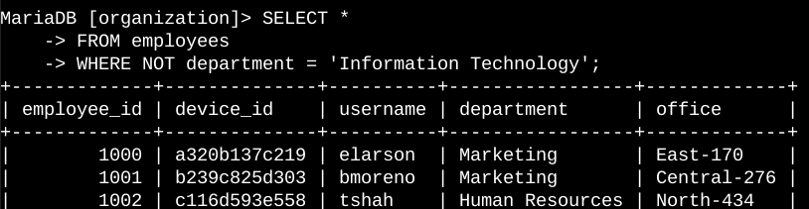
The query retrieves employees who do not belong to the Information Technology department. By selecting data from the employees table and utilizing a WHERE clause with the NOT operator, the query filters out employees who are in the Information Technology department. This allows for the retrieval of employees from other departments.

Summary
In my SQL queries, I effectively employed filters to extract specific information from the log_in_attempts and employees tables. By utilizing operators such as AND, OR, and NOT, I could refine the search criteria and retrieve the desired data. Additionally, I leveraged the LIKE operator along with the percentage sign (%) wildcard to filter for patterns within the data.
Through these techniques, I was able to narrow down the results and obtain targeted information related to login attempts and employee machines. The combination of table selection, operator usage, and wildcard filtering allowed me to efficiently gather the data.

